Roxas, Renz Joseph Y.

BSIT 3-B

Engaging activity

1. Make a simple Web Application using Flask that successfully displays the value of the inputted data from the HTML form and send the raw data to the URL.

Data to be inputted:

1. Your name

2. A fixed word “is”

3. Your characteristic

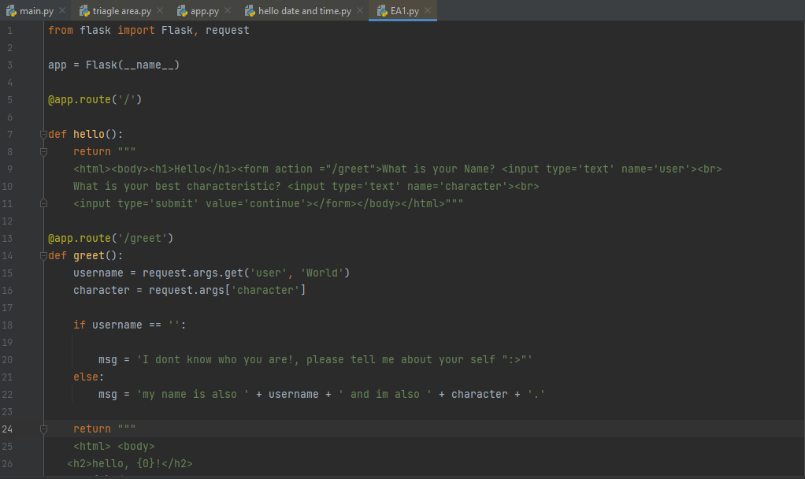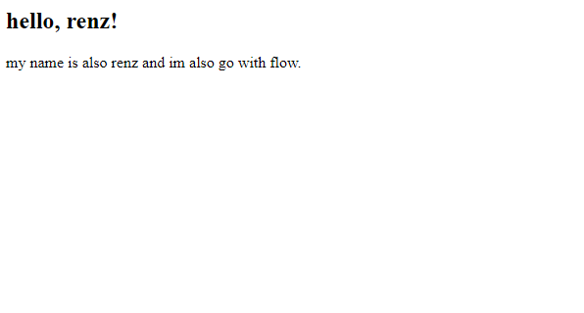

1. Do some coding trials based on your curiosity in this lesson and make at least 3-5 screenshots as a proof of your work discoveries.

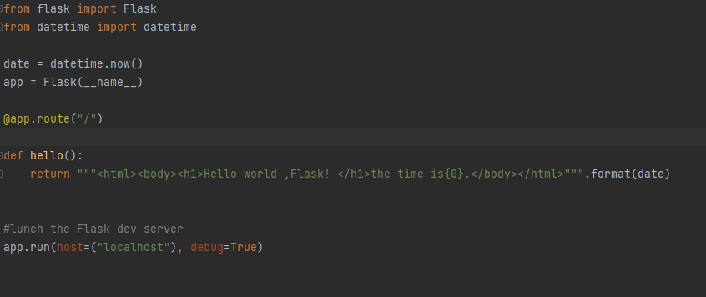

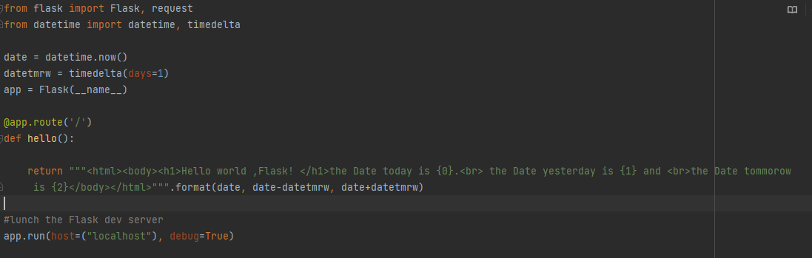

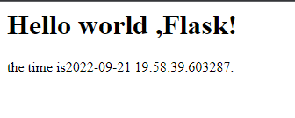

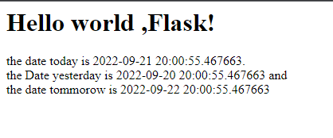

PT1

Directions: Identify what are the words describes in the given meaning or sentences below:

**1xx informational Response** 1. The message consists only of the status line and optional header fields, and is terminated by an empty line.

**HTTP request Methods** 2. When these requests are being sent, clients can use various methods.

**Query string** 3. In Web Development, what does this symbol ( ? ) means?

**URL(Uniform resource Locator)** 4. It has three sections: the protocol, the server where the document is located, and the path to the requested resource on the server.

**CONNECT request method** 5. Used by the client to create a network connection to a web server over a particular HTTP.

PT2

Directions: Answer the Guided Questions on this module.

1. How can I develop a Web Application using Python Programming Language?

- to develop a web application in python programing you need to use flask and call it as an app. app.run(host=(“localhost”), debug=True)

2. How does the Web Application works?

- so first of all, a Web Application is a software that runs on a web server. It is not stored on your pc like ordinary applications, web servers are programmed via Client-server model structure. Web applications follows the status code and are maintained via official registry system HTTP status codes.

1xx Information response

2xx Successful

3xx Redirection

4xx Client Error

5xx Server Error

3. Are there anything to be consider to create a Web Application using Python Programming Language?

- in my own opinion the connectivity of the user to his own creation and maybe based on my experience I’m not that fluent enough in python to embark the web development. I’m not yet that familiarize so I try java codes hoping it would also work on python but though luck it doesn’t. To conclude nothing much to consider in my point of view just study and learn how to do it in the end its all easy.